**FRONTEND IMPLEMENTATION OF AN ONLINE QR CODE-BASED ATTENDANCE SYSTEM**

**BY**

**IKOGWE ASSURANCE**

**PSC1808845**

**DEPARTMENT OF COMPUTER SCIENCE,**

**FACULTY OF PHYSICAL SCIENCES,**

**UNIVERSITY OF BENIN,**

**BENIN CITY,**

**EDO STATE, NIGERIA.**

**JUNE 2023**

**FRONTEND IMPLEMENTATION OF AN ONLINE QR CODE-BASED ATTENDANCE SYSTEM**

**BY**

**IKOGWE ASSURANCE**

**PSC1808845**

**A PROJECT REPORT SUBMITTED TO THE DEPARTMENT OF COMPUTER SCIENCE, FACULTY OF PHYSICAL SCIENCES, UNIVERSITY OF BENIN, BENIN CITY**

**IN PARTIAL FULFILMENT OF THE REQUIREMENT FOR THE AWARD OF A BACHELOR OF SCIENCE (B.Sc.) DEGREE IN COMPUTER SCIENCE**

**JUNE 2023**

# CERTIFICATION

This is to certify that this project work was carried out by **IKOGWE ASSURANCE** with Matriculation Number **PSC1808845** under my supervision. It is adequate and satisfactory, both in scope and content, for the award of Bachelor of Science (B.sc) Degree in Computer Science of the University of Benin

**PROF. (MRS.) A.O. EGWALI**

**DATE**

Project Supervisor

# APPROVAL

This project work is hereby approved in partial fulfilment of the requirements for the award of Bachelor of Science (B.Sc.) Degree in Computer Science from the University of Benin.

**PROF. (MRS.) A.O. EGWALI**

**DATE**

Head of Department

# DEDICATION

This project is dedicated to God Almighty for giving me the strength and wisdom to see it through to completion, and even throughout my stay in the University of Benin (UNIBEN). It is also dedicated to my parents; Mr and Mrs Ikogwe and my brother Master Benedict Ikogwe; for their love, support and guidance throughout my academic journey.

# ACKNOWLEDGEMENT

My utmost acknowledgement goes to God Almighty for giving me the strength, wisdom and direction throughout my academic journey. I would like to express my gratitude to my project supervisor who is also the Head of the Department Of Computer Science, Prof. (Mrs.) A.O. Egwali for her consistent guidance towards ensuring the successful completion of this project.

I would also like to specially thank my project coordinator Dr. (Mrs.) A.R. Usiobaifo, and other lecturers in the Department of Computer Science who I have been opportune to cross paths with, and have impacted me immensely these past few years: Prof. G.O. Ekuobase, Dr. F.O. Oliha, Prof. K.C. Ukaoha, Prof. A.A. Imiavan, Prof. (Mrs.) F. Egbokhare, Prof. (Mrs.) V.V.N. Akwukwuma, Prof. F.I. Amadin, Prof. (Mrs.) S. Konyeha, Prof. (Mrs.) V.I. Osubor, Dr. (Mrs.) Aziken, Dr. F.O. Chete, Dr. (Mrs) R.O. Osaseri, Dr. J.C. Obi, Mr. P. E.B. Imiefoh, Mr. I.E. Obasohan, Mr. S.O.P. Oliomogbe, Mr. K.O. Otokiti, Mr. I.E. obayagbonna, Mrs. R.I. Izevbizua, Mr. E.C. Igodan, Miss L.O.Usiosefe, Mr J. Okhuoya, Prof. F.A.U. Imouokhome, Mrs. J.I. Adun, Dr. E. Nweli and Mr. D.N. Idehen.

Finally, I also want to appreciate those who contributed to the success of this project: Abada Emmanuel Obaro, Felix Frank-Felix Ikechukwu, Omoruyi Esther Iyobosa, Onyibe Chukuwuazonim Justina, Oriakhi Cletus, and Osariemen Dainel Osazee. I would also like to thank my family and friends for their support, words of encouragement, and consistent guidance throughout this project.

TABLE OF CONTENTS

**CERTIFICATION i**

**APPROVAL ii**

**DEDICATION iii**

**ACKNOWLEDGEMENT iv**

**TABLE OF CONTENTS v**

**LIST OF FIGURES vii**

**LIST OF TABLES viii**

**ABSTRACT ix**

**CHAPTER ONE 1**

**INTRODUCTION 1**

1.0 Background Study 1

1.1 Motivation 3

1.2 Problem Definition 3

1.3 Goal and Objectives 4

1.4 Scope of Research 4

1.5 Research Methodology 4

1.6 Research Significance 4

**CHAPTER TWO 6**

**LITERATURE REVIEW 6**

2.1 Examination Attendance System: An Overview 6

2.2 Examination Attendance System in Nigeria Federal Universities 9

2.3 Traditional / Manual Attendance System 10

2.3.1 Roaster Method 11

2.3.2 Sign-Up Sheet 11

2.3.3 Seating Plans 11

2.4 Disadvantages of Traditional Attendance System 12

2.5 Automated Attendance System 13

2.5.1 Biometric: Face Recognition Attendance System 13

2.5.2 Radio Frequency Identification Technologies 14

2.5.3 Biometric: Fingerprint Attendance System 15

2.5.4 Bar Code Attendance System 16

2.5.5 Qr Code Attendance System 17

2.6 Benefits of Modern Attendance System 18

2.7 Qr Code Based Online Attendance System 20

2.8 Why Qr Code Based Online Attendance System 23

2.9 Related Works 24

**CHAPTER THREE 27**

**SYSTEM ANALYSIS AND DESIGN 27**

3.1 System Analysis 27

3.2 Analysis of Existing System 27

3.3 Problem of Existing System 29

3.4 Overview of Proposed System 29

3.5 Proposed System Architecture and Interface 30

3.6 System Design 35

3.7 System Design Tools 35

3.8 System Design Tool: UML 36

3.9 UML – Use Case Diagram 36

3.10 UML – State Machine Diagram 40

3.11 UML – Class Diagram 41

**CHAPTER FOUR 44**

**SYSTEM IMPLEMENTATION 44**

4.1 Software Implementation Tools 44

4.2 User Documentation – System Testing 45

4.3 Screenshots of the Running System 47

4.4 System Usability Evaluation 52

**CHAPTER FIVE 56**

**SUMMARY AND CONCLUSION 56**

5.1 Summary 56

5.2 Conclusion 57

**REFERENCES 58**

**APPENDIX 61**

# LIST OF FIGURES

Figure 1 - Examination Pass for 2020/2021 Academic Session. 8

Figure 2 - Examination Sign-up Sheet. 9

Figure 3 - Facial Recognition Attendance System (Alena, 2020) 13

Figure 4 - Radio Frequency Identification Attendance System (ETCS, 2023) 14

Figure 5 – Biometric Fingerprint Attendance System (Vitasek, 2021) 15

Figure 6 - Bar Code Attendance System 16

Figure 7 - QR Code Attendance System 17

Figure 8 - Statictics of smartphone users. (Turner, 2023) 19

Figure 3.1 Online QR Code Attendance System Architecture 27

Figure 3.2 Online QR Code Attendance System Interface 28

Figure 3.3 Use case Diagram for Student Profile 32

Figure 3.4 Use case Diagram for Admin Dashboard 33

Figure 3.5 State Machine Diagram for Attendance Tracking Status 35

Figure 3.14 Class Diagram for the Attendance System 36

Figure 4.1 Admin and Student's Login Page 39

Figure 4.2 NACOSS SMP Student’s Upload Page 40

Figure 4.3 NACOSS SMP Student’s Profile Page and QR Code Slip 40

Figure 4.4 NACOSS SMP Admin’s Dashboard 41

Figure 4.5 Exam Attendance Page 42

Figure 4.6 Take Attendance Page and the QR Code Scanner 43

Figure 4.7 Courses Page 43

Figure 4.8 Manage Admins Page (View, Add, and Delete admins) 44

# LIST OF TABLES

Table 2.1 Summary Table of Related Works 20

Table 3.1 Use Case Notations and Descriptions 28

Table 3.2 State Machine Diagram Notations and Descriptions 32

Table 3.3 Class Diagram Notations and Descriptions 33

Table 4.1 User’s Usability Scores Table 45

# ABSTRACT

Attendance tracking during examinations is one of the most important activities in any institution, as it directly influences the integrity of the examination process. So far the manual methods adopted like use of seating plans, examination pass, roaster call, etc. have proven to be inadequate, extremely time consuming and labor intensive amongst other disadvantages.

This project emphasis on the need to adopt more automated methods of attendance tracking during examinations, these methods includes biometric attendance systems, bar code attendance systems, radio frequency identification attendance systems, etc. Taking into consideration the constraints and the scope of the project which is the University Of Benin, Department Of Computer Science, the method proposed by this project is an Online QR code-based Attendance System.

However, this project focuses on only the front-end implementation of this automated attendance system, where students can upload their course registration slips, download their QR Code Slip and the attendance is recorded by scanning the QR code on this slip. This project makes use of the Object oriented approach to system analysis and design; use case, class and state machine diagrams were used to represent designs for the system architecture. These designs served as the framework for the system, the system can handle the whole process of attendance tracking, from student validation to providing an attendance record for the various courses offered by the Department Of Computer Science.

# CHAPTER ONE

# INTRODUCTION

## Background Study

In most universities, during examinations, there is a need for an attendance; to ensure that students are present during their scheduled exams and to maintain the integrity of the examination process. The methods of taking exam attendance vary between universities and even between departments of the same universities.

It started by employing manual means like **roaster or student id checks,** where a roaster or class list containing the picture and other details of the student is in the possession of the invigilator. Every student signs or marks their presence on the roaster or provides their identification number.

There’s also the use **sign-in sheet w**here students sign in their names and provide their identification number and exam booklet number. Lastly, another traditional method is the use of **seating plans,**students sits according to their assigned serial number, and their attendance is verified by matching their presence with the seating plan.

These manual methods have a lot of disadvantages; it is incredibly time-consuming and labor-intensive as it needs the involvement of several staff members, and requires a lot of resources to implement. And it is paper-driven; papers can be easily misplaced or tampered with.

However, with the advancement in technology and the explosion of the internet and the World Wide Web, methods such as **online attendance systems**; which involves the students logging into a designated platform with their credentials and taking their attendance digitally has been developed. This method is ineffective, as a student not slated for the examination can partake in the process, compromising the integrity of the examination process.

Another method is the**bar-coded or scannable examination cards**,issued to the students by the university and swapped upon entry into the examination halls. The student’s attendance is then automatically recorded. This method also has disadvantages; it requires a **barcode scanner**, which emits light and collects reflected light to decode the barcode. It is labor intensive (must be scanned individually) and susceptible to environmental damage. If scratched or crumpled, barcodes may cause problems in scanning (RF, 2012).

Lastly, we have **biometric identification systems**; these systems utilize fingerprint or facial recognition technology to identify and record the presence of students. Students register their biometric data beforehand, and the system matches it during the exam attendance process.

This method is time-consuming (scanned individually) and expensive to implement. However, after an in-depth analysis of the methods highlighted in the paragraphs above, considering their challenges, we propose an **Online QR Code-Based Attendance System**. It eliminates the limitations posed by the bar code, as it can hold more information. A QR code can go up to 2500 characters, and 25 characters for a barcode. (Rentman, 2011).

QR codes are easier to read than barcodes, as you have to aim the barcode scanner in line with the bar code; a QR code can be scanned even with a mobile phone, also when you have many items to capture, you won’t have to align the mobile phone precisely every time. QR codes work even when damaged; they have a high error correction margin. So even if around 30% of the code is unreadable (erased, damaged, dirty), the code still works (Rentman, 2011).

This system is built specifically for the University of Benin, Department of Computer Science, beforehand; the department makes use of examination pass to ensure that students present have registered for their courses, as they submit their course registration slips to obtain their examination pass and the sign in sheets to account for the student’s booklet number for cases of missing scripts.

This project is concerned with creating an alternative to the examination pass; as it is immensely stressful for the students, they have to queue up at the department before getting their exam pass. It also stands the risk of falsehood, during the just concluded examination, a student (Frank-Felix, 2023) testified concerning how another student made a fake copy of the examination pass. The proposed system as stated above, is an online QR code-based attendance system with two sides, the user side where the students sign in to the online platform with their emails and matriculation number, upload their course registration slip, from there we get to know the examinations the student is slated for. The student is then given a pdf file containing the unique QR code as well as his/her details, this QR code is then scanned, to take the student’s attendance for that examination. At the end of the day, the lecturer can login in at the administrator side of the platform to get the examination attendance for each course.

## Motivation

Examinations are an integral part of any institution, an attendance system must be in place to checkmate malpractice and ensure the overall integrity of the entire process. In federal universities, where lecturers have to deal with a large population of students, manual means of taking attendance will not stand the test of time. It therefore means that there is a need to leverage on existing technologies so as to provide a stress-free, fast, less labor-intensive method of accounting for the student’s attendance in examinations.

## Problem Definition

In Nigeria, Federal universities account for the university with the highest population of students (Sasu, 2023), having this in mind; conducting examinations are usually very stressful for both the academic and non-academic staffs. One of their major concerns is how to maintain the integrity of the examination process, for this to be possible there has to be an adequate examination attendance system. The manual approach adopted so far cannot accurately and efficiently account for the attendance given the population of the students. There is also the issue of impersonation, where a student not slated for an examination writes the paper for another student; so far the measures erected to curb this are still not sufficient enough. Even with an examination pass, the integrity of the examination is still not catered for; as students can present fake ID’s which the said invigilator may fail to identify. With the advancement of technology, the methods invented are either time consuming, requires a lot of resources to implement or labor intensive. There is a need for a system that will not break the pockets of the university, less labor intensive and takes advantage of technology.

## Goal and Objectives

The goal of this research project is to provide the University of Benin, Department of Computer Science an alternative to the traditional means of validating student’s course registration and taking exam attendance. The system aims achieve the following objectives:

1. To create a system for validating course registration.
2. To develop a computerized exam attendance system.
3. To develop a system compatible with the current university system.
4. To develop a system that promotes user accessibility and user experience.
5. To enable real-time attendance tracking.

## Scope of Research

This project focuses of the front-end implementation of an online Qr code-based attendance system, built to take examination attendance of students, using the University of Benin, Department of Computer Science as a case study.

## Research Methodology

This project made use of Object-Oriented Analysis and Design Methodology (OOAD), which is the process of analysing and designing a system as a set of components and objects. It made use of the observation approach for analysis of related and relevant documents on the area of interest to establish the need and necessity of the proposed system and after that ended with a conclusion and summary.

## Research Significance

With the advancement in technology and the need to cater for the attendance needs of the Department of Computer Science, UNIBEN, given its large population; this online QR code-based attendance system will help to realise the following:

1. It would help the department ensure that every student registers their course, thereby curbing the issues arising from late/no registration of courses by students.
2. It would help the department account for the examination attendance of students for every semester with ease; even providing a permanent record of examination attendance that will not consume any physical space, as against the use of papers.

# CHAPTER TWO

# LITERATURE REVIEW

This chapter gives an overview of examination attendance systems from a global perspective. It went further to narrow it down to Nigeria and more specifically Federal Universities with the University of Benin, Department of Computer Science as a case study. It then discusses the traditional/manual attendance system, their disadvantages, the modern attendance system and the benefits of using them.

## Examination Attendance System: An Overview

The concept of examination was invented in the late 19th century by an American Businessman and a philanthropist named Henry Fischel; China was the first country to implement this concept nationwide and conducted the first-ever examination known as the Imperial Examination (Aishwarya, 2023). The imperial examination was introduced by the Sui Dynasty in 605 Ad to recruit candidates for specific government posts, the system was considered to select people based on merit rather than birth (Aishwarya, 2023).­­

This concept has grown beyond China and its now adopted in most, if not all parts of the world as a system for grading of not just candidates of a particular government post, but also in job recruitment by companies and majorly in academics for grading students’ performance in all aspects, that is in sports, in academics, etc.

Examinations usually require the physical presence of the students, however due to the COVID19 pandemic, a number of activities previously undertaken on campus are becoming online activities; this includes exams, so we now have physical and online exams (Frederiks, 2021). Regardless of whether it’s a physical or online exam, there are majorly three (3) types of examinations namely:

1. **Closed Examination:** In these exams, the student is allowed to bring only his/her writing and drawing instruments. In the case of mathematics and statistics exams, formula sheets may or may not be provided (Frederiks, 2021).
2. **Restricted Examination:** Here, the students are only allowed to bring specific things such as a single page of notes, or in the case of maths exams, a calculator or a formula sheet. You may also be required to hand in your notes or formula sheet with your exam paper. (Frederiks, 2021)
3. **Open Examination:** These exams allow you to have access to any printed or written material and a calculator (if required) during the exam. If you are completing your exam online, you may also be able to access online resources. The emphasis in open book exams is on conceptual understanding and application of knowledge rather than just the ability to recall facts. (Frederiks, 2021)

With the concept of examination introduced, there arises the need for an appropriate attendance system for the following reasons:

* 1. To curb academic impersonation during examination.
  2. To keep record of students present for the examination process.
  3. To keep track of student’s booklet number.
  4. To maintain the integrity of the examination process.

Examination attendance system spans from using the pen and paper approach to taking leverage of technology using automated systems. So, therefore there are two main types of attendance systems namely:

1. **Traditional / Manual Systems:** Here we have roaster and student id checks, sign-up sheets, and seating plans, etc.
2. **Automated Systems:** The examples here are face recognition, RFID systems, biometric systems, code scanning, etc.

Regardless of the type of attendance system used, an attendance system must consist of two components namely:

1. **Authentication:** The attendance must include a means of verifying whether the said student is a student of that faculty or department and if he or she is slated for the current examination.
2. **Attendance Tracking:** The attendance system must also have a means of accounting for the record of students present for the examination.
   1. **Examination Attendance System in Nigeria Federal Universities**

In Nigeria, most federal universities make use of the examination sign-up sheet in conjunction with the student’s identification card (ID card) as their examination attendance system. In the University Of Benin, the focus of this research paper; all her faculties and departments alike adopts this attendance system for their examination process.

This research paper focuses on the Department of Computer Science; where students are required to register their courses online, pay their respective dues and then collect their examination pass from the department. A picture of the examination pass is shown below

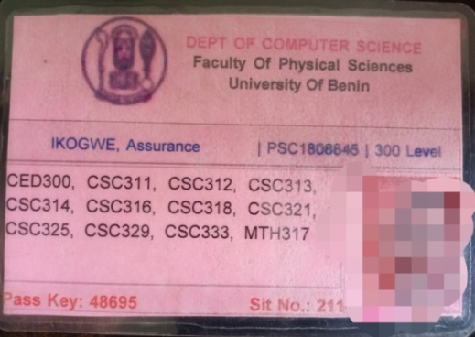

Figure - Examination Pass for 2020/2021 Academic Session.

On the slated day for an examination, the examination pass serves as a means of authenticating the student, as you can see in Figure 1 above, it contains the students name, matriculation number, passport photograph and the list of courses the student registered. A sign-up sheet is also used as to take the attendnace of the student, that is to verify that a student was present in the exam hall for his/her exam.

This sign-up sheet contains the following fields: serial number, name, matriculation number, faculty code (e.g PSC for Physical Science), department code (e.g CSC for Computer Science), the examination booklet number and the student’s signature; a structure is seen below

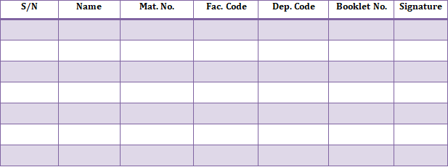

Figure - Examination Sign-up Sheet.

With the population of students’ federal universities, such as the University Of Benin have to cater for; you guess right! This traditional method is very ineffective and incredibly time wasting, as well as labor intensive. Before going forward, it is necessary to reiterate that this research paper focuses on the University Of Benin, Department of Computer Science, analysing her examination system and providing an alternative solution to the current system.

* 1. **Traditional / Manual Attendance System**

A manual attendance system is a traditional system that requires students to fill in attendance sheets manually, although it comes with some advantages like it is cheaper to implement, it is simple to use, and does not involve the use of internet connection, but it comes with a lot of disadvantages that cannot be ignored.

Manual examination attendance systems can vary between universities and even across different departments within the same university, but some of the known methods are:

1. Roaster Method
2. Sign-in Sheet
3. Seating Plans

Each of these methods is briefly discussed in subsequent sub sections below. In manual examination attendance system, student ID card is usually used for the authentication process. Student ID checks entail confirming the identities of students by contrasting their physical characteristics with the identification cards supplied by their universities. Prior to entering the exam room or during the exam session, invigilators may ask students to submit their ID cards for visual inspection.

This technique aids in preventing unauthorized people from utilizing false identities or taking the exam on behalf of others. Student ID checks offer a manual method to verify the legitimacy of students and guarantee that only those who have enrolled for the exam take part.

* + 1. **Roaster Method**

A printed list or roster containing the picture and other details of the student who have enrolled for a specific exam is used for roaster checks. Exam overseers or invigilators call out student names to confirm attendance or ask them to sign next to their names on the roaster.

Invigilators can manually record student attendance using this technique. It makes it easier to account for and accurately grade pupils who show up for the test. Checks for roasters might be made at the entry to the exam room or when the test takers receive and turn in their answer papers.

* + 1. **Sign-Up Sheet**

Students personally offer their signatures or write their names on physical sheets or forms on which sign-up papers are used to record their attendance during exams. These sheets are often passed out to students before to or during the exam, and invigilators or exam supervisors collect them. Sign-up sheets act as a manual record of attendance, enabling vigilance personnel to confirm each student's attendance. Students affirm their participation in the exam and recognize their attendance by signing or writing their names.

* + 1. **Seating Plans**

Here, individual students are given specific seats or positions within the exam room according to seating plans. Typically, these strategies are developed beforehand and shared with the students in advance of the test. Invigilators check for attendance during the exam by comparing occupied seats to the designated seating arrangement. Seating arrangements help with attendance tracking, order maintenance, and cheating prevention, among other things.

Invigilators can quickly detect absentees or unauthorized individuals during the exam by assigning each student to a specific seat. A disciplined and regulated method of managing attendance during exams is provided by seating plans. They provide accurate attendance tracking, make it easier to identify pupils who are present, and contribute to the integrity and fairness of the testing environment.

* 1. **Disadvantages of Traditional Attendance System**

Although manual attendance systems have been in use for a while, they have a number of shortcomings. In order to address these drawbacks and enhance attendance monitoring procedures, many institutions are switching to digital solutions, such as the online QR code-based attendance systems. These disadvantages include:

1. **Incredibly Time-Consuming:**

Particularly in large educational institutions, manual attendance methods can be quite time-consuming. During each examination, manually recording attendance can take up a significant amount of time, including calling out names, checking IDs, and distributing sign-up sheets.

1. **Labor-Intensive and Involvement of Several Staff Members:**

Several staff members, such as invigilators, teachers, or administrative staff, are frequently needed to implement manual attendance systems. To check attendance, gather sign-up forms, or keep attendance records, these people must be present. It can be time-consuming, especially while the examinations are going on at once during busy times.

1. **Requires a Lot of Resources to Implement:**

Staff training, the printing of documents (such rosters or sign-up sheets), and administrative work to monitor attendance data may all be required for manual attendance systems. When compared to automated or digital attendance solutions, the costs of manual systems can be significant.

1. **Paper-Driven and Prone to Misplacement or Tampering:**

Physical paper-based records, like sign-up sheets or attendance registers, are the foundation of many manual attendance systems. The system is subject to problems like misplacing, losing, or purposeful tampering because of this reliance on paper. Paper-based solutions run a higher risk of losing attendance data as a result of handling errors or mishaps.

1. **Inevitable Errors During Data Entry:**

Human mistake is possible with manual data entering. Errors can happen while entering attendance information into a spreadsheet, roster, or database. The accuracy of attendance records might be impacted by frequent problems including typos, omissions, or misreading handwriting.

* 1. **Automated Attendance System**

An automatic attendance system is an educational ERP system that records the students’ attendance in an institution, unlike the traditional attendance system; the automatic attendance software enables the faculty to record, store, and monitor students’ attendance history (Ahmed, 2021).

There are several ways in which attendance can be automated; they include (Ahmed, 2021) :

1. Marking attendance via school mobile app
2. Marking attendance via biometric identification
3. Marking attendance via Radio Frequency Identification (RFID)
4. Attendance marking powered by face recognition (real-time)

Each of these methods is briefly discussed in subsequent sub sections below.

* + 1. **Biometric: Face Recognition Attendance System**

Due to the recent development of machine learning and neural networks, face recognition applications still help greatly, accurately and efficiently. The attendance monitoring system is a very important process in all institutions, several facial recognition attendance systems has been developed, each with its strengths and weaknesses, and used in different fields. This type of automated attendance system generally consists of steps such as **image acquisition**, **database development**, **pre-processing**, and **face detection** (Khaled, 2022).

This is an attendance management system using face recognition techniques by taking pictures from cameras and comparing them to the student's photo database after training the system on students' faces in advance (Khaled, 2022). Face recognition is a significant research issue that crosses many areas and fields. A computer program that can recognize, track, identify, or authenticate human faces from an image or video taken with a digital camera is also available.

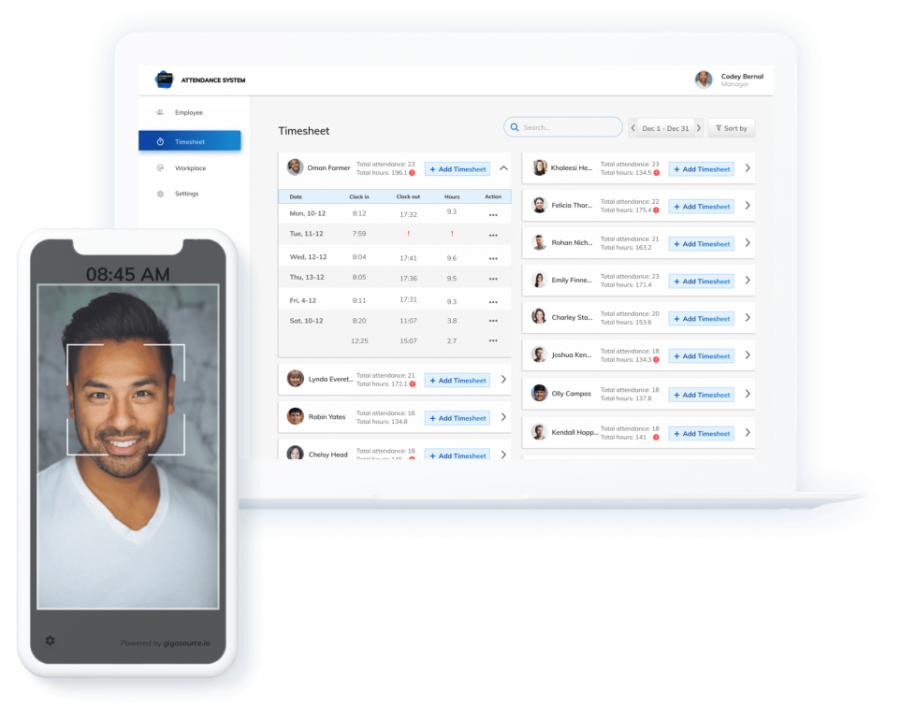

Figure - Facial Recognition Attendance System (Alena, 2020)

* + 1. **Radio Frequency Identification Technologies**

RFID is a technology that is used to collect information automatically by radio frequency data communication between a mobile object and an RFID reader, to identify, categorize and track them (Rajan, 2012). They are most commonly referred to as tag and reader respectively. To retrieve the data stored on an RFID tag, need a reader. A typical reader is a device that has one or more antennas that emit radio waves and receive signals back from the tag. It is used to read or write information on a tag and passing that information to a system for storage and processing (Rajan, 2012).

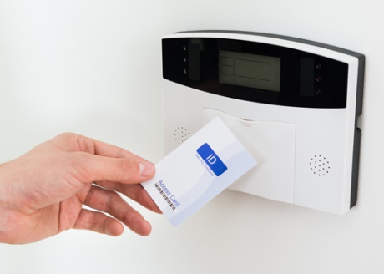

Figure - Radio Frequency Identification Attendance System (ETCS, 2023)

* + 1. **Biometric: Fingerprint Attendance System**

Biometric-based attendance system recognize a person identity based on the biological characteristic such as **fingerprint**, **hand geometry**, **voice**, **retina**, **iris** and **face recognition** which reliably distinguishes one person from another or used to recognized the identity. They have five subsystems: **data collection**, **signal process**, **matcher**, **storage and transmission** (Cheah, 2015). Gina (2020) proposes a system whose data includes student, invigilator, examination and venue registration entered by the faculty / examination administrator and then stored in a data storage subsystem. The system will then use the data to populate an examination timetable as well as an attendance sheet for each registered examination. The invigilator then accesses this attendance sheet after verification and dispenses it to the students walking into the examination hall. The system then marks the attendance of the authenticated students using a **fingerprint authentication system**. The attendance sheet is then saved by the system and stored for later retrieval

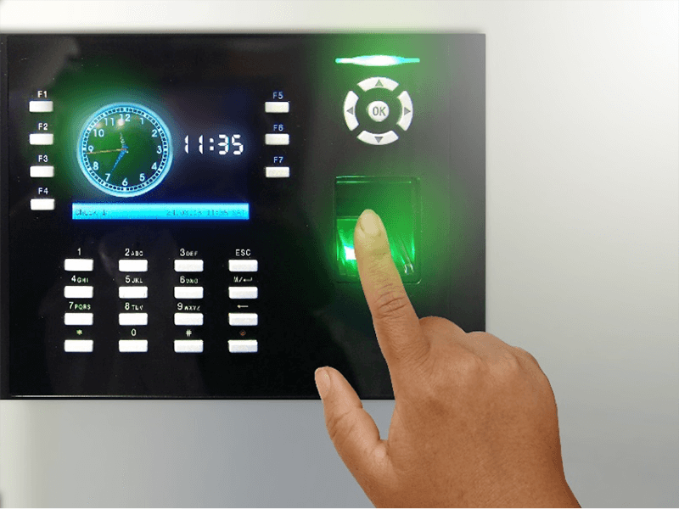

Figure – Biometric Fingerprint Attendance System (Vitasek, 2021)

* + 1. **Bar Code Attendance System**

A barcode is a set of parallel lines and spaces with various widths that serves as a visual representation of data. It is used to store and transmit data in a machine-readable format about a good, thing, or object. Barcodes are frequently seen on retail items, books from the library, shipping labels, and a variety of other objects.

A barcode's primary function is to encode data in a way that makes it simple for readers or scanners to scan and decode it. These readers employ laser beams to recognize the barcode's contrasting patterns of black bars and bright gaps. Depending on the type of barcode symbology utilized, the information contained in the barcode can be expressed as numbers, letters, or a combination of both.

Each student receives a special bar code that serves as a representation of their identification in the bar code attendance system. Students provide their bar code on a printed ID card or a mobile device during exams so that it can be read by a bar code reader. The student's attendance is noted in a digital database when the scanner reads the code. Figure 6 below shows the image of a bar code



Figure - Bar Code Attendance System

* + 1. **Qr Code Attendance System**

QR or Quick Response Codes are matrix barcodes that can be easily read by smartphones and dedicated QR reading devices. QR code was designed by Denso-Wave for the automotive industry in Japan, 1994. The inventor has made open source and free for human being, QR codes also store data in both directions and can be scanned vertically or horizontally (Rehman, 2018).

Although it has more features like in terms of storage a barcode can represent up to 25 characters, a QR code can go up to 2500 (Rentman, 2011) and the fact that barcode scanning requires special device called **Barcode scanner** which emits light and collects reflected light to decode the Barcode (RF, 2012); the QR code attendance system functions similarly to the bar code system. Smartphones or special QR code scanners can read QR codes, which are more information-dense than regular bar codes. Figure 7 below shows the image of a QR code

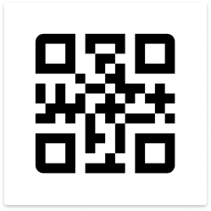

Figure - QR Code Attendance System

* 1. **Benefits of Modern Attendance System**

Numerous advantages of automated attendance systems allow for more accurate, simple, and effective attendance tracking for both students and educational institutions. These benefits have encouraged numerous educational settings to embrace digital methods for managing attendance. They include:

1. **Less Time-Consuming:**

The amount of time needed to take attendance is greatly decreased by automated solutions. Students can rapidly check in or out using techniques like scanning QR codes, swiping ID cards, or biometric recognition thanks to automated systems. By streamlining the process, both students and teachers can benefit from time savings that free up more time for practical teaching and learning activities.

1. **Not Labor-Intensive:**

Automated attendance solutions don't require staff members to manually record attendance. Once configured, the system runs without the requirement for on-going management or assistance from numerous staff members. This lessens the workload on administrative staff and frees them up to concentrate on other crucial tasks.

1. **Minimal or No Use of Papers:**

A digitally operated automatic attendance system typically does not require paper-based records. Utilizing less paper thanks to this eco-friendly strategy promotes environmental sustainability. Additionally, it reduces the possibility of lost or destroyed paper attendance records.

1. **Data Integrity and Tamper-Proof:**

Data generated automatically by electronic methods in automated attendance systems is less vulnerable to manipulation or tampering. Since digital records are often saved safely in databases, it is challenging for unauthorized parties to change attendance information. Thus, the reliability and correctness of attendance records are guaranteed.

1. **Eliminates Inevitable Errors in Data Entry:**

Automated attendance systems lessen the likelihood of errors by doing away with the need for human data entry. Automated methods collect attendance data reliably and without human intervention, in contrast to manual data input, where errors may arise owing to typos or incorrect handwriting interpretation.

1. **Real-Time Data and Reporting:**

Real-time information on student attendance is provided through automated attendance systems. In order to monitor attendance trends, spot patterns, and respond appropriately when necessary, instructors and administrators have fast access to the most recent attendance data. Better decision-making and intervention techniques are facilitated by real-time reporting.

1. **Enhanced Data Analysis:**

Integrated data analysis features are frequently included with automated attendance systems. Institutions can learn more about student involvement, class participation, and general attendance patterns by tracking attendance data over time. These discoveries can help initiatives for student progress and inform instructional tactics.

* 1. **Online Qr Code-Based Attendance System**

Smartphone usage has revolutionized the world to many settings including that of the education system with numerous potential and realized benefits. While the functions of smartphones, such as text messaging, multimedia, and Internet connectivity, may seem purely recreational, they can be used within the academic institution to manage student’s attendance to speed up the process of taking attendance by academic instructors, hence reduces time, human errors and redundant works as compared to the manual attendance system (Rehman, 2018).

Figure 8 shows the statistics of smart phone users from 2017-2022, you’ll notice that the number as grown exponentially over the years, almost every house hold, if not all have access to a smart phone.

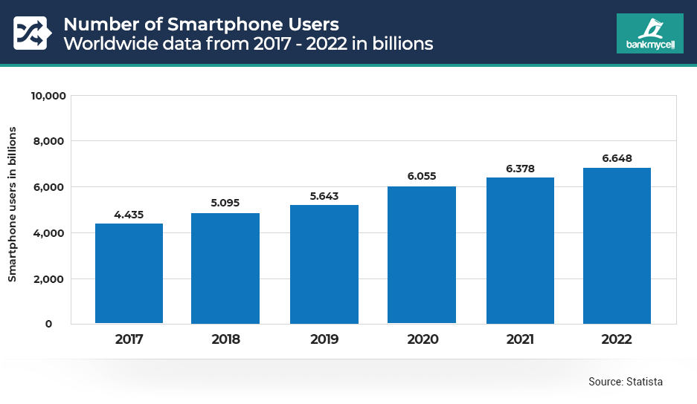

Figure - Statictics of smartphone users. (Turner, 2023)

The Qr-code based online attendance system leverages on this smart phone technology as a tool for recording the participation of students in an examination by storing the student’s data on a QR code which is then scanned to account for that student’s attendance.

Attendance systems using bar codes and QR codes provide effective, automated attendance tracking during exams. The bar code system is easy to use and reasonably priced, but the QR code system offers other advantages including greater data capacity, smartphone compatibility, and contactless operation.

The institution's unique requirements, financial constraints, and desired level of functionality will determine which of the two systems it chooses. So, taking the University of Benin, Department of Computer Science, her operations, financial constraints, etc. into consideration QR code presents itself as the only logical way to go in terms of attendance tracking.

* 1. **Why Online Qr Code-Based Attendance System**

In the realm of automated attendance systems, online QR code-based attendance stands out as the optimal choice due to its numerous advantages over other systems like face recognition, fingerprint, barcode, and RFID attendance systems. The widespread usage of smartphones and the simplicity of implementation allow QR code technology to revolutionize attendance management by offering a quick, simple, and affordable fix. In contrast to existing automated systems, the study examines the distinctive features of the online QR code-based attendance system, highlighting its adaptability and applicability for various educational settings. Below are some of the reasons for choosing QR code based online attendance system:

1. **Universal Accessibility and Convenience:**

QR codes can be created and scanned using generally available cellphones, both students and instructors can use the system. Instead than requiring specialist hardware like facial recognition or fingerprint systems, QR codes make use of already-existing technology, allowing for seamless integration with minimal infrastructure investments. Reduce wait times and ensure efficient attendance tracking by allowing students to easily mark their attendance with a quick scan.

1. **Non-Intrusive and Contactless Operation:**

QR code-based attendance operates in a non-intrusive and contactless manner, in contrast to facial recognition or fingerprint systems that demand close physical proximity. During public health emergencies, this non-intrusive strategy protects students' privacy and reduces health worries. Additionally, individual and simultaneous QR code scans can be made, easing the process of taking attendance at large-scale events.

1. **Cost-Effectiveness and Simple Implementation:**

When compared to other automated systems, QR code-based attendance systems provide a more affordable option. Due to the lack of sophisticated infrastructure needs or specialized technology, it is an affordable option for educational institutions with tight budgets. Additionally, creating and dispersing QR codes is a simple procedure that needs little staff or student training.

1. **Real-Time Data Collection and Analytics:**

Real-time data gathering and analytics are made possible by the online QR code-based attendance system, allowing for quick attendance tracking and recordkeeping. Instantaneous access to attendance data by institutions makes it easier to intervene quickly and make informed decisions. Additionally, the system's analytics capabilities provide insightful data on attendance trends, helping to improve institutional performance evaluation and student engagement methods.

1. **Cross-Platform Compatibility:**

QR codes can be included into a variety of digital platforms, including online portals, mobile apps, learning management systems (LMS), and mobile applications. By ensuring smooth connection with current educational tools, this compatibility promotes a strong digital ecosystem. In contrast, barcode or RFID systems can experience compatibility issues, which would restrict their adaptability and integration options.

As the most popular option for automatic attendance management, the online QR code-based attendance system stands out for its accessibility to all users, non-intrusive operation, affordability, and real-time data collection capabilities. QR codes have unparalleled versatility and ease of use when compared to facial recognition, fingerprint, barcode, and RFID systems, making them perfect for various educational contexts. Adopting online QR code-based attendance solutions is a crucial step towards streamlined attendance management and a digitally empowered learning environment as educational institutions aim for better efficiency and effectiveness.

* 1. **Related Works**

The research paper of Hamadan (2021) suggests a QR code-based attendance system that makes use of a mobile app to scan customized QR codes for each classroom.Almasalha (2014) paper proposes a QR code-based attendance system that uses smartphones to speed up the process of taking attendance by university instructors.

Talib (2018) research paper discusses the use of a QR code-based attendance system during exams; the technology generates QR codes for each student and each exam, which are scanned by a mobile application. With a focus on QR code-based solutions, Abdalkarim (2022) paper reviews the research on smart attendance systems.

Abdullahi (2018) proposes an examination eligibility verification system using QR code, the EEV system was validated using a smartphone to scan the QR code generated.

Sujyot (2023) paper proposes an attendance system that uses QR codes to identify students, teachers, and other staff members, making it a fast and efficient way to keep track of attendance. In the study by Ebenezer (2021), the attendance system makes use of QR code for attendance taking developed for Ajayi Crowther University.

Table 2. Summary Table of Related Works

|  |  |  |  |
| --- | --- | --- | --- |
| **Author(s)** | **Year** | **Objectives** | **Major Features** |
| Mohd Syazwan Hamdan, Mohd Izuddin Mohd Yasin, Wan Nazmi Wan Mohd Nor, Mohd Radzi Abdul Rashid | 2021 | To develop a QR code system for taking attendance in classroom. | The system verifies three types of information: geolocation, registered mobile device, and subject class hour. |
| Fadi Almasalha, Nael Hirzallah | 2014 | To develop a QR code system for taking attendance in classroom. | The system generates a QR code for each student, which is displayed at the beginning of each lecture. Students scan the code to confirm their attendance. |
| Aisha Talib, Bothainah Ahmed, Khadija Abdullah AL-Saidi, Justin Rajasekaran | 2018 | To develop a QR code system for taking attendance in examinations | The technology generates QR codes for each student and each exam, which are scanned by a mobile application. |
| Bawar Ali Abdalkarim, Dakgun Sakarya | 2022 | To review smart attendance systems with a focus on QR based solution. | This paper talks about smart attendance systems in general, highlighting the advantages of QR code system over the rest. |
| Abdullahi, Muhammad Bashir, Nura, Zahra’u Musa, Jiya, Lawal Musa | 2018 | To design and develop an examination eligibility verification system (EEV) using QR code. | Design: UML  Front-end: JavaScript, CSS, HTML5  Back-end: PHP and MySQL |
| Sujyot Raut, Prajwal Bhure, Parag Bariye, Ashish Nandeshwar, Prof. Jayant Adhikari | 2023 | To develop a system that uses QR codes to identify students, teachers, and other staff members, making it a fast and efficient way to keep track of attendance | The system consists of two main components:  Back-end: managing the database of users, classes, and attendance records.  Front-end: user interface that allows teachers and students to interact with  the system |
| Ebenezer Oyebode, Taiwo Oyedepo | 2021 | To develop an attendance system that uses QR code for Ajayi Crowther University | Methodology: SDLC  SDLC model: V-model  Implementation language: PHP |

# CHAPTER THREE

# SYSTEM ANALYSIS AND DESIGN

This chapter provides a model of the development process while offering an overview of the system design and system analysis.

1. **System Analysis**

System analysis is a crucial stage in the life cycle of software development that entails a thorough analysis of an existing system or the specifications for a new system. In order to create efficient solutions, a system's features, components, processes, and interactions must be understood, documented, and defined.

There are several methods of system analysis and design, the two major methods include:

1. **The Object-Oriented Analysis and Design (OOAD) Method**
2. **Structured System Analysis and Design (SSAD) Method**

The Object-Oriented Analysis and Design (OOAD) Method **(**OOAD) was used for this project because the main goal of OOAD is to provide an effective and well-organized software solution that solves practical issues. Understanding the issue domain, creating modular, reusable components, and making sure the resultant system is scalable, maintainable, and adaptive to changing requirements are all key components of the OOAD methodology.

* 1. **Analysis of Existing System**

As stated in chapter two, the existing system is a traditional attendance system which includes the use of an examination pass shown in Figure 2.1 above; this pass serves as a means of authentication. It is prepared from the student’s course registration slip; it contains the student’s passport photograph, name, matriculation number, and the registered courses.

For the actual attendance tracking a signup sheet is used, the students enter their serial numbers, names, matriculation number, faculty and department codes, booklet number and signature. This is used to record the attendance for each course, any student whose details do not appear on the sheet is assumed to be absent for that examination.

A lot of time and resources is spent preparing and printing this examination card for each student, considering the huge population the department has to cater for. There is also the risk of forgery of this examination pass, which will tamper with the integrity of the entire examination process as a result of impersonation.

The signup sheet is a paper driven approach, it can be tampered with as a student can write for another student who wasn’t present for the examination, there’s also the issue of misplaced signup sheet, with this there will be no attendance record for that examination process. With all these put into consideration, tilting to more modern approaches of examination attendance tracking is the best way to go.

* 1. **Problem of Existing System**

As stated in chapter two, the following are the problems of the traditional attendance system adopted by universities:

1. Due to activities like name calling, ID checks, and sign-up sheet distribution, manual attendance methods, particularly in larger institutions, take up a significant amount of time during sessions or events.
2. Relying on physical paper records, like sign-up sheets, makes manual systems susceptible to issues such as loss, misplacement, or intentional tampering, risking data integrity.
3. Manual systems demand resources for document printing, and administrative efforts to manage attendance data, leading to higher costs compared to automated solutions.
4. Manual data entry is prone to human errors like typos or omissions when transferring attendance information to spreadsheet, rosters, or databases, potentially affecting record accuracy.
   1. **Overview of Proposed System**

The proposed system is named NACOSS SMP, it leverages on technology to provide a more automated method for attendance tracking in examinations. It is an online based QR code attendance system where attendance is tracked by scanning a student’s QR code. For this system to completely achieve its goals, it must be able to perform the following functions:

1. It will enable students to upload their course registration slip in pdf format only.
2. It will provide a QR code slip for the students that contain their details and unique QR code obtained from their uploaded course registration slip.
3. It will enable admins to view and download student’s data which consists of the student’s name, matriculation number, the number of courses registered, and the data registered.
4. It will enable admins to view the exam attendance summary which consist of the courses code, courses title, number of student’s registered and present for each course
5. It will provide admins with a QR code scanner for taking the attendance of each student for a particular course.
6. The system will enable the admin to view and download the attendance record of each course.
7. The system will make provision for only one admin i.e. the super admin who will be able to add and remove other admins
   1. **Proposed System Architecture and Interface**

The attendance system is a full web application; it is made up of several interconnected components as shown in Figure 3.1. It would contain a page for students to upload their course registration slip which is then stored on a server, the student’s profile and QR code is generated from the data; this slip can be downloaded from the profile. On the day of the slated examination, the student’s QR code is scanned to record his/her attendance for that particular course; this attendance record is stored on the server.



Figure 3. Online QR Code Attendance System Architecture

As stated earlier, Figure 3.1 above shows the system architecture that is the different components that makes up the system, Figure 3.2 below shows the system interface which shows how these different components interact with each other. It starts with a login as an admin (lecturer) or a user (student). From the student side, the students can either view their profile or download their QR code slip just after uploading their course registration slips.

At the admin end, the lecturer can take attendance or download the attendance data for a particular course, but first has to select the course at the Exam Attendance Page or Courses Page respectively, then he/she can scan the students QR code or download the attendance record.

**Upload course registration slip**

**Login**

**Download QR Code**

**Select user**

**Take Attendance**

**Download Course Attendance**

**Login**

**Scan Student’s QR Code**

**Download Attendance File (CSV File)**

**Select Course**

**View Profile**

Figure 3.2 Online QR Code Attendance System Interface

* 1. **System Design**

The process of defining the architecture, interfaces, and data for a system that complies with particular requirements is known as system design. It is a multidisciplinary field that entails trade-off analysis, weighing competing requirements, and making choices regarding design decisions that will have an impact on the entire system. A methodical approach to developing and engineering systems is necessary for system design.

* 1. **System Design Tools**

The creation of precise plans, diagrams, and specifications for software systems is aided by the use of system design tools. System architectures, components, interactions, and other design elements can be represented visually with the help of these tools. Common types of system design tools include:

1. **Unified Modelling Language (UML):** UML is a disregarded language that is used to specify how software systems should be visualised, built, and documented. It is an essential tool for creating object-oriented software and the software development process, and it is independent of any specific programming language or method.
2. **Data Flow Diagram (DFD):** A data flow diagram is a tool used to explain the movement of data through a system and the operations or processing that it carries out. It displays how data enters the system from external sources, how it travels from one process to another, and how it is logically stored. Making a context diagram is a good idea. Every symbol used in the context diagram is also acceptable in the DFD.
3. **System Flowchart:** The system flow chart is a diagrammatic representation that shows how a system operates; this is easier to understand than reading a long text. One of the main tools a system analyst uses to display a high-level picture of the operations in an entire system is a system flow chart. It has more advantages than programme flow charts that merely show the direction of data flow, displaying the alphabetical order of operation symbols.
4. **Entity- Relation Diagram:** This displays the entities and connections that the data describes. It can refer to a group of people, places, things, occasions, or even concepts. These relationships include:
5. One to one – a driver – drive a car
6. One to many- a teacher teaches many students at a time
7. Many to many – many readers read many books.
8. Many to one – many students reading a school.
   1. **System Design Tool: UML**

Unified Modelling Language, also known as UML, is a standardised modelling language that consists of a collection of integrated diagrams. It was created to assist system and software developers in defining, visualising, building, and documenting the artefacts of software systems as well as business modelling and other non-software systems. Creating object-oriented software and the software development process both heavily rely on the UML. The UML primarily employs graphical notations to convey software project design.

* 1. **UML – Use Case Diagram**

A use case diagram is a dynamic or behaviour diagram in UML that models the functionality of a system using **actors** and **use cases**. The **actors** are people or entities operating under defined roles within the system. The **use cases** are a set of actions, services, and functions that the system needs to perform. In this context, a "system" is something being developed or operated, such as a website.

Table 3. Use Case Notations and Descriptions

|  |  |  |
| --- | --- | --- |
| Objects | Symbols | Description |
| Actors |  | These are the people who interact with the system. An actor is a person, a group, or an external system that interacts with the application or system. They must be external data producers or consumers. |
| Use case |  | A use case is a collection of tasks, services, and operations that the system must carry out. It aids in capturing the system's features and how users interact with it without delving into the system's implementation's internals. |
| System | **System name** | The term "system" refers to the complete software application or software system in question. It depicts the system being analysed, created, or simulated, which is the subject of the use cases. |
| Relationship | **<<include>>**  **<<extend>>** | This represents the association or connection between different elements within the diagram. There are three main types of relationships namely:  **1. Association:** It represents a simple relationship between two elements. It shows that one element is associated with or related to another element in some way.  **2. Include:** This is used to show that one use case includes or incorporates the functionality of another use case. It represents a behaviour that is common to multiple use cases and is included as a step within each of them  **3. Extend:** It indicates that one use case can be enhanced by another use case. It represents alternative behaviour that may be added under specific conditions. |

**Student**

**Student Profile**

Figure 3. Use case Diagram for Student Profile

**Lecturer (admin)**

**Admin Dashboard**

**<<include>>**

**<<include>>**

**<<include>>**

**<<include>>**

**<<include>>**

**<<include>>**

Figure 3. Use case Diagram for Admin Dashboard

* 1. **UML – State Machine Diagram**

A state machine is any device that stores the status of an object at a given time and can change status or cause other actions based on the input it receives. State diagrams mainly depict states and transitions. States are represented with rectangles with rounded corners that are labelled with the name of the state. It illustrates the states and transitions of an object or system. In the context of the online QR code-based attendance system, the state machine for a student's attendance status can be marked, not marked, scan QR code etc.

Table 3. State Machine Diagram Notations and Descriptions

|  |  |  |
| --- | --- | --- |
| Objects | Symbols | Description |
| First State |  | A marker for the first state in the process, shown by a dark circle |
| Terminator |  | A circle with a dot in it that indicates that a process is terminated. |
| State | **State** | A rectangle with rounded corners that indicates the current nature of an object. |
| Transition Arrow |  | An arrow running from one state to another that indicates a changing state. |
| Choice Pseudostate |  | A diamond symbol that indicates a dynamic condition with branched potential results. |
| Exit Point |  | The point at which an object escapes the composite state or state machine, denoted by a circle with an X through it. |

Student’s course reg.slip has been uploaded

**Admin logged in**

**Display Error message**

**Scan QR code**

**Update Attendance Record**

Student’s course reg.slip not uploaded

Figure 3. State Machine Diagram for Attendance Tracking Status

* 1. **UML – Class Diagram**

One of the more popular types in UML is the class diagram, popular among software engineers to document software architecture, class diagrams are a type of structure diagram because they describe what must be present in the system being modelled.

A Class Diagram provides a visual representation of the system's classes, their attributes, and relationships. In the front-end implementation of the online QR code-based attendance system, the following classes can be identified: Student, QR code, Lecturer, AttendanceRecord, AttendanceSystem, etc.

Table 3. Class Diagram Notations and Descriptions

|  |  |  |
| --- | --- | --- |
| Objects | Symbols | Description |
| Aggregation |  | A diamond-shaped line with a solid line connecting two classes, indicating a whole-part relationship. |
| Dependency |  | A dashed line with an arrowhead indicating a relationship between two classes where changes in one class might affect the other class. |

**USER (STUDENT)**

**+name: string**

**+matriculation number: string**

**+email: string**

**+uploadPdfFile()**

**+login()**

**+logout()**

**QRCODE**

**+image: jpg**

**+storeStudentDetails()**

**+name: string**

**SUPER ADMIN**

**+email: string**

**+login()**

**+addAdmin()**

**+removeAdmin()**

**+scanQrCode()**

**+viewStudentDetails()**

**+downloadStudentData()**

**+downloadAttendanceData()**

**+exportStudentQrCode()**

**ADMIN (LECTURER)**

**+name: string**

**+email: string**

**+login()**

**+scanQrCode()**

**+viewStudentDetails()**

**+downloadStudentData()**

**+downloadAttendanceData()**

**+exportStudentQrCode()**

Figure 3. Class Diagram for the Attendance System

# CHAPTER FOUR

# SYSTEM IMPLEMENTATION

1. **Software Implementation Tools**

This project focuses on only the front end implementation of an online QR based attendance system; the following software tools were used:

1. **Implementation Languages**: The following are the various programming languages used for the project’s implementation:
   1. **Hyper Text Markup Language (HTML)**: This is the markuplanguage used in creating the content, building structure and defining the semantic of the web page.
   2. **Cascading Style Sheet (CSS)**: This language was used to define the visual representation and styling of the HTML elements in the web page. It was used to control the layout, colors, fonts, spacing, and overall design of a webpage.
   3. **JavaScript**: This is a scripting language that is primarily used for adding interactivity and dynamic behavior to websites and web applications. It was to create interactive user interfaces, handle user input, manipulate data, and perform various actions on a web page without requiring a page reload.
2. **Implementation Framework**: Frameworks are pre-built groups of code and tools that serve as the basis for creating applications in software development. By providing reusable elements, patterns, and conventions, they give an organized approach to development. The frameworks used during this project are:
   1. **ReactJs**: This is a JavaScript front-end framework focused on building dynamic and interactive user interfaces for web applications. It excelled in creating component-based architectures, managing UI state, handling user interactions, and efficiently updating the DOM.
   2. **Tailwind CSS**: This is a CSS framework focused on simplifying the process of styling web applications by providing a collection of utility classes that cover a wide range of design aspects. It was particularly useful for rapidly creating responsive designs and maintaining consistent styling across an application.
3. **Implementation Platforms**:Visual Studio Code (VS Code) is a widely popular, free, and open-source code Integrated Development Environment developed by Microsoft. It is an excellent choice for building web applications, regardless of the operating system you are using and integration to Version Control System like Git and Github which was the remote Version Control System.
4. **Deployment Platforms**: For making the web application available to all users, it was deployed using vercel. Vercel is a cloud platform designed to facilitate the deployment and hosting of web applications and websites. It specializes in providing a seamless experience for developers to deploy projects, particularly those built using modern frameworks like ReactJs.
5. **Operating System**: This project is a full web application that was built using the Windows operating system, a very user friendly and developer-friendly system.
   1. **User Documentation – System Testing**

System testing is a vital stage in the software development life cycle that entails thorough testing of a software application or system as a whole. System testing tries to make sure that all parts and modules of the program function properly as an integrated system and adhere to the requirements. The following was tested:

1. The login and logout functionality for the student.
2. The login and logout functionality for the admin (lecturers)
3. Are students able to upload their course registration slip in pdf format only?
4. Are the students able to view their profile?
5. Are students able to get their QR code slip after upload?
6. Is the super admin able to add and remove other admins?
7. Are the admins able to see the details of students that have uploaded their course registration slip for each level?
8. Are the admins able to scan the student’s QR slip during the day of the slated examination?
9. Are the admins able to view the exam attendance details for each course?
10. Are the admins able to download the attendance list for the different courses?
    1. **Screenshots of the Running System**

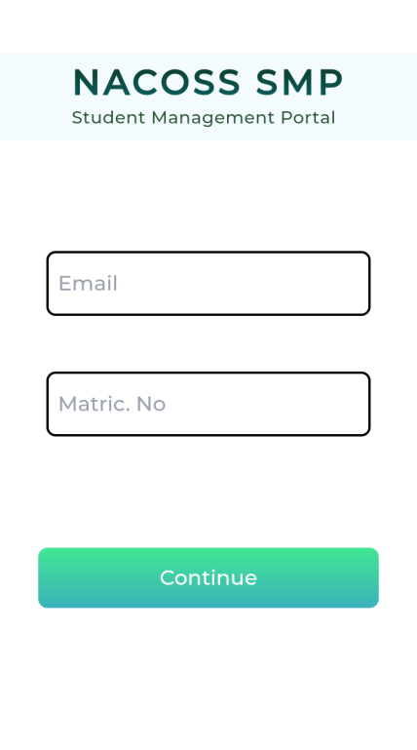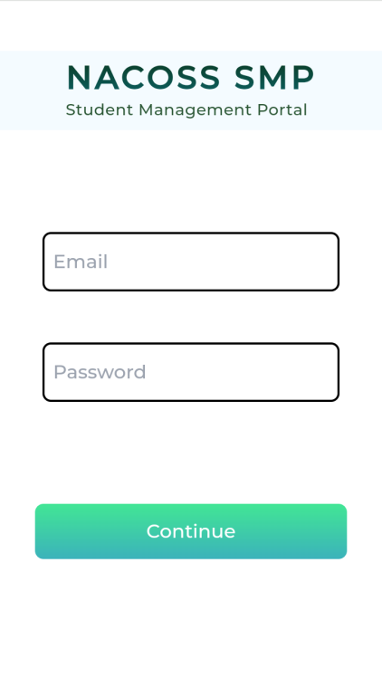

Figure 4.1 Admin and Student's Login Page

Figure 4.1 shows the login page of NACOSS SMP for the admins and students; the admins login with their **“email address”** and **“password”** while the students login with their **“email address”** (preferably their university email) and their **“matriculation numbers”**.

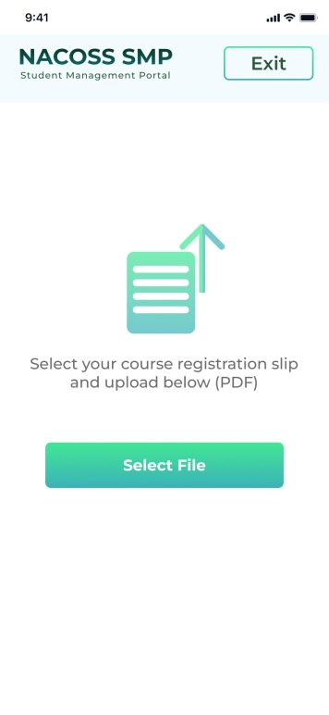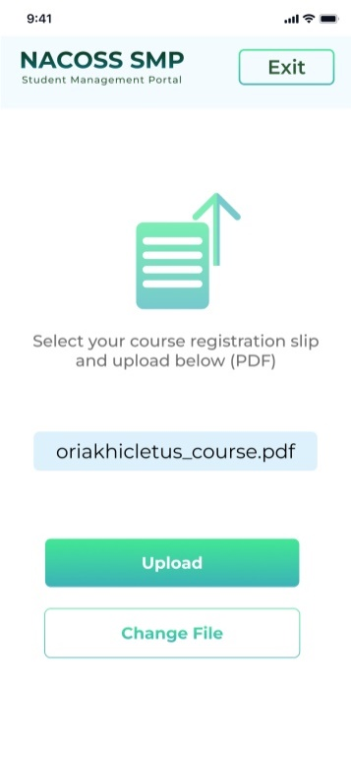

Figure 4.2 NACOSS SMP Student’s Upload Page

Figure 4.2 shows the upload page, where the students have to upload their course registration slip in **.pdf** format as downloaded from their **student’s kofa page**.

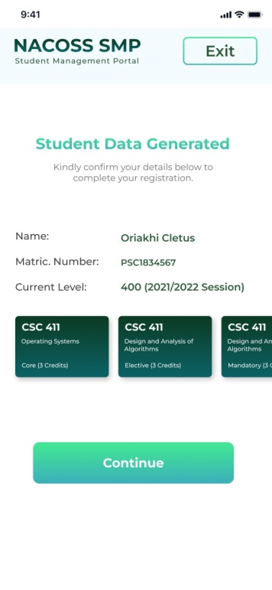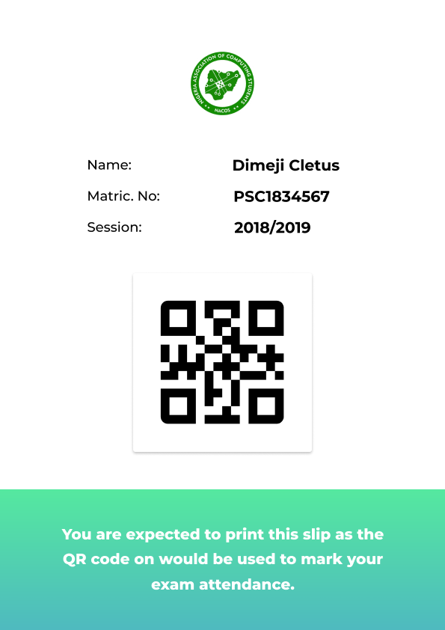

Figure 4.3 NACOSS SMP Student’s Profile Page and QR Code Slip

As soon as the student uploads his or her course registration slip, a slip contain his or her unique QR code is sent via the email he or she provided while logging in, Figure 4.3 above shows this and the student’s profile page which includes all the student details i.e. Student’s Name, Student’s Matriculation Number, Student’s Current Level and the Student’s Registered Courses as drawn from the uploaded course registration slip.

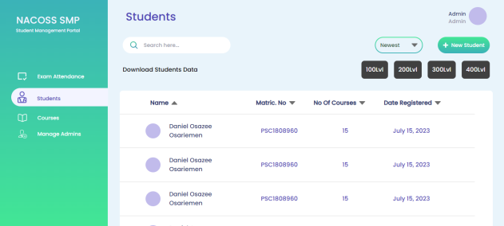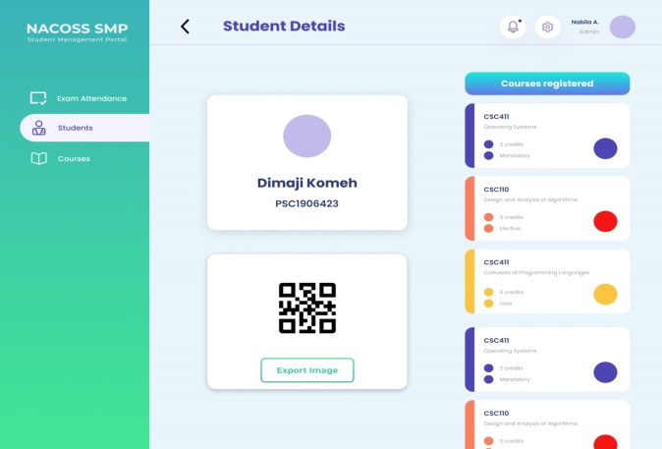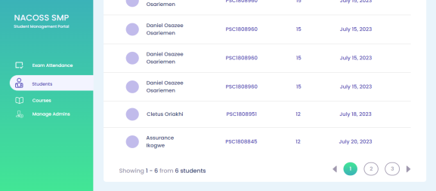

Figure 4.4 NACOSS SMP Admin’s Dashboard

In Figure 4.4 above, the snapshot on the left shows the details of students that have uploaded their course registration slip and this data can be downloaded for each level; the details are gotten from the slip, it includes student’s name, matriculation number, number of courses, date of course registration. Clicking on a student leads the admin to another page, the snapshot on the right of Figure 4.4; this shows the student’s name and matriculation number on one card, the student’s QR code on the other card, and the courses registered cards on the right side of the page.

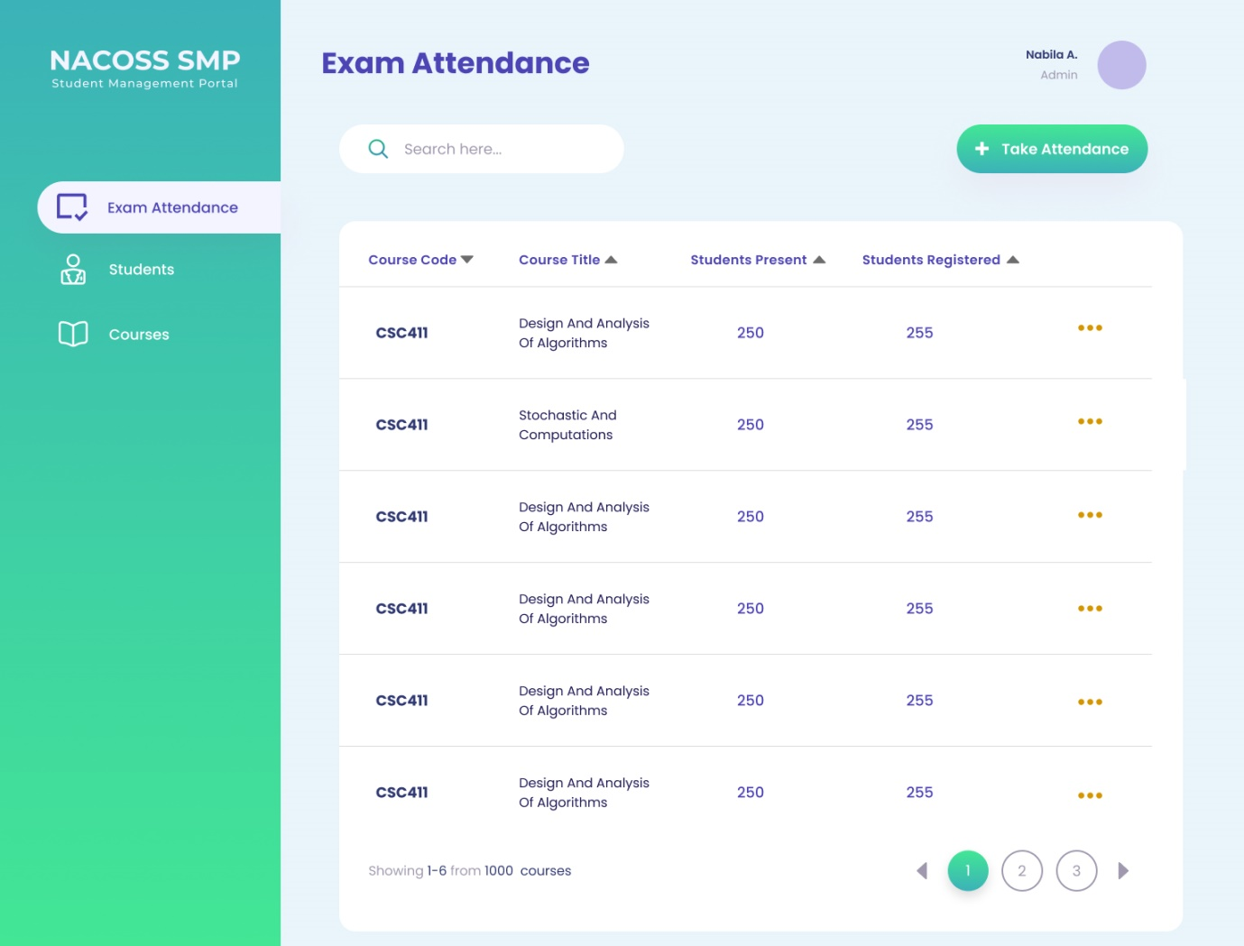

Figure 4.5 Exam Attendance Page

Figure 4.5 shows each course to be done per semester, including the number of students registered for the course, as well as the number of students present for the examination which is derived from the number of students QR slip scanned during the day of the slated examination. Clicking on a course takes the admin to the take attendance page shown in Figure 4.6 below.

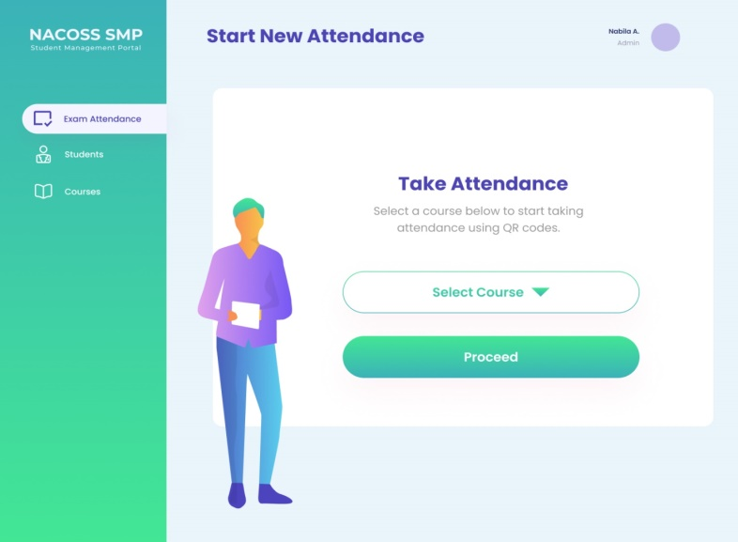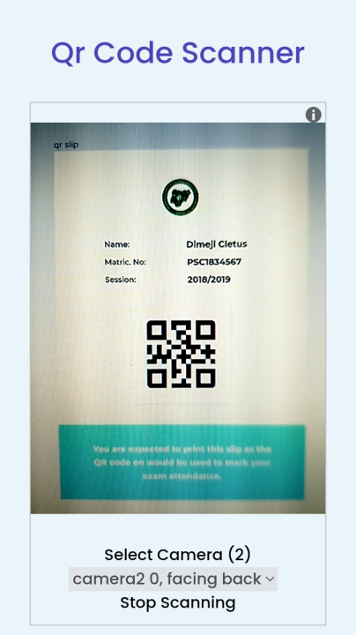

Figure 4.6 Take Attendance Page and the QR Code Scanner

The admins can take attendance for a particular course on the take attendance page which is shown on the snapshot on the left in Figure 4.6. The snapshot on the right shows the QR code scanner which scans the QR code on a student’s QR code slip and then records the attendance of the student for that particular course.

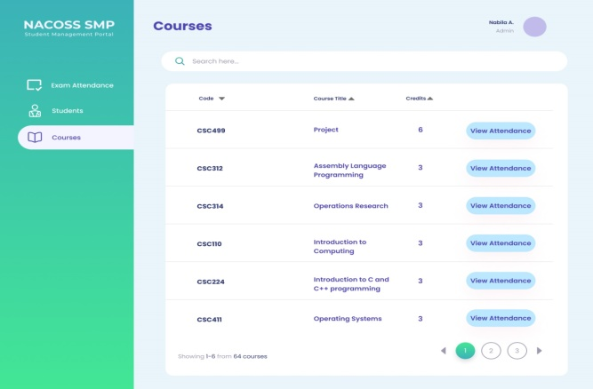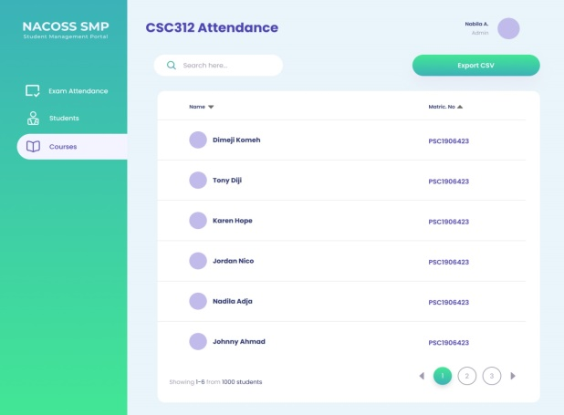

Figure 4.7 Courses Page

The attendance data is a csv file, to download it the admin has to navigate to the courses page on the admin dashboard which is shown in the left snapshot in Figure 4.7, it contains the course code, title, credit and a button to view attendance for a particular course. On click of the “View Attendance” button, the user is directed to another page that contains the attendance data for that course which includes the names and matriculation number of every student present for the examination whose QR code slip was scanned. The page also contains an “Export CSV” button that downloads the attendance data for each course.

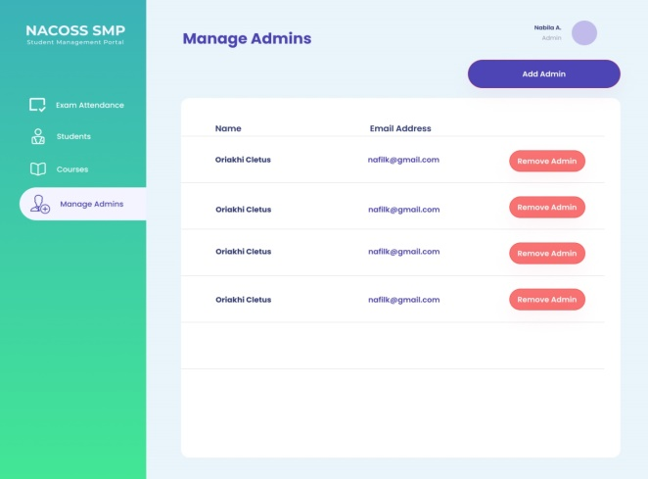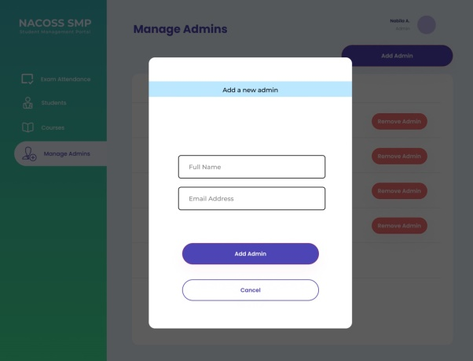

Figure 4.8 Manage Admins Page (View, Add, and Delete admins)

NACOSS SMP makes room for only one admin which is known as the super admin, which is the Head of Department (HOD); this super admin can in turn add other lecturer (course advisers for each level) as admins, Figure 4.8 provides the pages for adding and removing admins.

* 1. **System Usability Evaluation**

The System Usability Scale (SUS) is a widely used questionnaire-based tool for assessing the usability and user-friendliness of software, websites, and digital systems. John Brooke invented it in the 1980s, and it has since become a popular tool for analysing user experiences. The SUS consists of a series of questions that users must answer to offer a quantitative measure of usability that may be used to compare different systems or track development over time.

The SUS is especially useful for gaining insights about users' perceptions of a system's general usability. It covers both subjective and objective aspects of usability, providing vital feedback to designers and developers on how well a system corresponds with user expectations and needs.

The SUS questionnaire comprises ten statements, and participants respond to each statement using a 5-point Likert scale, ranging from "Strongly Disagree" to "Strongly Agree." The scale includes options:

1. Strongly Disagree.
2. Disagree.
3. Neutral.
4. Agree.
5. Strongly Agree.

The SUS is scored by converting the replies into numerical values and then applying a formula to calculate the final usability score. The possible values range from 0 to 100, with higher scores suggesting improved usefulness. A SUS score of 70 or more is considered above average, while a score of 85 or higher indicates great usability.

The SUS score can provide vital insight into how well an Online Attendance and Student Management System project is meeting user needs and expectations. The SUS questionnaire can be used to collect feedback on the system's usability, user-friendliness, and overall experience from peers who are trying the system. This feedback can assist to uncover strengths and weaknesses in the system's design and functionality, allowing for changes to the user experience and the creation of a platform that is more closely aligned with the needs of its users.

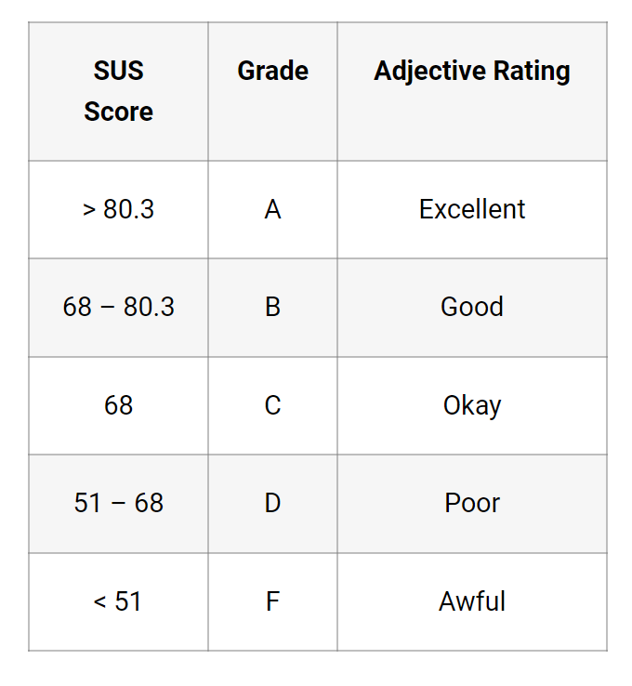

**Source: *https://uiuxtrend.com/measuring-system-usability-scale-sus/***

The usability test questionnaire was created using the following clear and concise questions. The system was then tested with ten users and feedback was gathered using this questionnaire.

1. I found the system to be easy to use.
2. I needed to learn a lot of things before I could get going with the system.
3. The various functions in the system are well integrated.
4. I would imagine that most people would learn to use this system very quickly.
5. I found the system very intuitive to use.
6. I needed to rely heavily on technical support to use the system.
7. The system has too many inconsistencies.
8. I felt very confident using the system.
9. I needed to learn a lot of things before I could accomplish tasks.
10. Overall, I am satisfied with the system's usability.

Table 4. User’s Usability Scores Table

|  |  |
| --- | --- |
| **User** | **SUS Score** |
| User 1 | 52.5 |
| User 2 | 90.0 |
| User 3 | 77.0 |
| User 4 | 47.5 |
| User 5 | 65.0 |
| User 6 | 92.5 |
| User 7 | 85.0 |
| User 8 | 72.5 |
| User 9 | 50.5 |
| User 10 | 82.5 |
| **Total** | **715** |

Based on the table above, the total usability score is 715. The average score which is gotten by dividing the total score by the number of users (10 users) is 71.5. According to the SUS Grade and Rating Table in Fig 4.10 above, the average usability score of the system falls at the 68 - 80.3 mark, therefore the system can be classified as good to use.

# CHAPTER FIVE

# SUMMARY AND CONCLUSION

1. **Summary**

With the advancement in technology, the traditional methods of taking examination attendance like use of seating plans, signup sheets, roaster calls, etc. are no longer sufficient as they are labor intensive, incredibly time consuming, requires a lot of resources to implement, and most especially very error prone. We must then seek modern approaches that will eliminate all these shortcomings by providing automated systems that are less labor intensive, not error prone as data entry is automatic, etc.

A platform such as NACOSS SMP, which leverages on technology to provide a more modern approach to tracking examination attendance in the Department of Computer Science, University Of Benin. The goal of this project is to provide the University of Benin, Department of Computer Science an alternative to the traditional means of validating student’s course registration and taking exam attendance. This web application uses the Object-Oriented Analysis and Design (OOAD) approach for the analysis and design of its system. This full web application leverages on the course registration slip provided to the students by the university management.

The students login with their emails and matriculation number and are then directed to a page where they are to upload their course registration slip, the information on this slip is used to create a profile for them and a QR code slip is sent to their mails, this slip contains their unique QR code which holds the information on their course registration slip. The Students Page of the admin dashboard automatically updates after each student completes their upload, this data can be downloaded for each level. To take attendance the admin navigates to the Exam Attendance Page and selects the particular course, a QR code scanner is then use to record the attendance of the students.

To view the attendance data, the admin navigates to the Courses Page where he/she selects a course and gets redirected to a page where the course attendance can be downloaded as a csv file. The web application only provides room for one admin which is known as the super admin; this super admin can in turn add and remove admins by navigating to the Mange admin Page.

* 1. **Conclusion**

This project covers the attendance system used by different universities during their examinations; it narrowed it down to federal universities in Nigeria and then finally taking the Department of Computer Science, University Of Benin. It analysed the traditional method of examination attendance tracking used namely examination pass, sign-up sheets, etc. It also highlights the disadvantages of traditional attendance tracking and emphasizes on the need of a manual attendance system. The solution introduced is NACOS SMP; an Online QR code-based Attendance System which leverages on technology (internet, smart phones and QR codes) to provide a less labor intensive, faster, and efficient way of attendance tracking during examinations.

# REFERENCES

Abdullahi, M. B. (2018). Examination Eligibility Verification and Attendance System Using Quick Response Code. *i-manager's Journal on Digital Signal Processing (JDSP)*, 1-9.

Ahmed, M. (2021, January 5). *Automatic Attendance System - Advantages Of Automated Attendance System*. Retrieved July 19, 2023, from MasterSoft: https://www.iitms.co.in/blog/automated-student-attendance-management-system-for-schools-and-colleges.html

Aisha Talib, B. A.-S. (2018, October). *Effect of implementing 'QR Code Attendance System' during Examination in SHCT-Limits and Possibilities*. Retrieved July 18, 2023, from Research Gate: https://www.researchgate.net/publication/328306138_Effect_of_implementing_'QR_Code_Attendance_System'_during_Examination_in_SHCT-Limits_and_Possibilities

Aishwarya, R. (2023, January 25). *Who Invented Exams? - Origin of Exams, History*. Retrieved July 10, 2023, from Get My Uni: https://www.getmyuni.com/articles/who-invented-exams

Alena, D. (2020, March 27). *Top 5 Face Recognition Attendance Software – Free & Premium.* Retrieved July 19, 2023, from gigasource.io: https://gigasource.b-cdn.net/wp-content/uploads/2020/01/attendance-img2.png

Bawar Ali Abdalkarim, D. S. (2022, July). *A Literature Review on Smart Attendance Systems*. Retrieved July 18, 2023, from Research Gate: https://www.researchgate.net/publication/362405196_A_Literature_Review_on_Smart_Attendance_Systems

Cheah, M. M.-S. (2015). Sensors-enabled Smart Attendance Systems Using NFC and RFID Technologies. *International Journal of New Computer Architectures and their Applications*, 5(1) 19 -28.

Ebenezer Oyebode, T. O. (2021). QR–code attendance system for Ajayi Crowther University. *Computer Science Series (19)*, 23-25.

ETCS. (2023). *Employee Time Clocks – Compare Cloud Based Time Tracking Software.* Retrieved July 19, 2023, from Employee Time Clock Systems: https://employeetimeclocksystem.com/wp-content/uploads/2016/12/rfid-based-attendance-system.jpg

Fadi Almasalha, N. H. (2014, January). *A Students Attendance System Using QR Code*. Retrieved July 18, 2023, from Research Gate: https://www.researchgate.net/publication/275605455_A_Students_Attendance_System_Using_QR_Code

Frank-Felix, F. (2023, June 19). Falsification of Examination Pass. (I. Assurance, Interviewer)

Frederiks, e. (2021). *Academic Success*. Retrieved July 18, 2023, from Types of Exams: https://usq.pressbooks.pub/academicsuccess/chapter/types-of-exams/

Gina, B. A. (2020, February). *Biometric Examination Attendance Taking System (BEATS).* Retrieved July 22, 2023, from Research Gate: https://www.researchgate.net/publication/339401785_Biometric_Examination_Attendance_Taking_System_BEATS

Khaled, A. J. (2022). An attendance system for exams using face recognition Based on MTCNN and OpenCV algorithms. *International Science and Technology Journal*, 1 - 12.

Mohd Syazwan Hamdan, M. I. (2021, September 24 - 27). *QR Code-Based Student Attendance System*. Retrieved July 18, 2023, from IEEE Xplore: https://ieeexplore.ieee.org/document/9681472/

Rajan, N. P. (2012). Online Students‘ Attendance Monitoring System in Classroom Using Radio Frequency Identification Technology: A Proposed System Framework. *International Journal of Emerging Technology and Advanced Engineering*, 2( 2) 62 - 64.

Rehman, V. C. (2018). Mobile Barcode Based Examination Attendance System. *International Journal of Engineering & Technology*, 7 (3.22) 49-54.

Rentman, B. (2011). *QR codes vs barcodes: Which should you use for equipment?* Retrieved June 24, 2023, from Rentman Blog: https://rentman.io/blog/qr-vs-barcodes-what-should-you-use-for-your-av-equipment

RF, W. W. (2012). *Advantages of Barcode | disadvantages of Barcode*. Retrieved June 24, 2023, from Home of RF and Wireless Vendors and Resources: https://www.rfwireless-world.com/Terminology/Advantages-and-Disadvantages-of-Barcode.html

Sasu, D. D. (2023, Feburary 6). *Universities in Nigeia - statistics and facts*. Retrieved June 25, 2023, from Statista: https://www.statista.com/topics/8520/university-in-nigeria/#topicOverview

Sujyot Raut, P. B. (2023). QR CODE BASED ATTENDANCE SYSTEM. *International Research Journal of Modernization in Engineering Technology and Science* , 421-427.

Turner, A. (2023). *HOW MANY SMARTPHONES ARE IN THE WORLD.* Retrieved July 19, 2023, from bankmycell: https://www.bankmycell.com/blog/wp-content/uploads/2018/07/number_of_smartphone_users_worldwide-2022.png

Vitasek, e. (2021, March 23). *Here’s How To Choose The Best Biometric Attendance System According To Your Organization Size.* Retrieved July 19, 2023, from The World Financial Review: https://worldfinancialreview.com/wp-content/uploads/2021/03/Biometric-copy.png

# APPENDIX

**SOURCE CODE**

**USER PAGES**

**Login Page**

import React from "react";

import { Header, Form } from "../../Components/UserComponents";

export default function Login() {

return (

<section className="user">

<Header />

<Form

user={"student"}

firstInputPlaceHolder={"Email"}

secondInputPlaceHolder={"Matric. No"}

firstInputId={"name"}

secondInputId={"mat-no"}

firstInputType={"name"}

secondInputType={"text"}

for={true}

/>

</section>

);

}

**Upload Page**

import React from "react";

import { Header2, FileUpload } from "../../Components/UserComponents";

import { useLocation } from "react-router-dom";

export default function Upload() {

const location = useLocation();

const { state } = location;

return (

<section className="user flex flex-col space-y-24">

<Header2 />

<FileUpload email={state} />

</section>

);

}

**Success Page**

import React from 'react'

import {Header3, Successful} from '../../Components/UserComponents/index'

export default function Success() {

return (

<section className='user flex flex-col space-y-8'>

<Header3 />

<Successful />

</section>

)

}

**Profile Page**

import React from "react";

import { Header2, FileUpload } from "../../Components/UserComponents";

import { useLocation } from "react-router-dom";

export default function Upload() {

const location = useLocation();

const { state } = location;

return (

<section className="user flex flex-col space-y-24">

<Header2 />

<FileUpload email={state} />

</section>

);

}

**ADMIN PAGES**

**Login Page**

import React from "react";

import { Form, Header } from "../../Components/UserComponents";

export default function AdminLogin() {

return (

<section className="user">

<Header />

<Form

user={"admin"}

firstInputPlaceHolder={"Email"}

secondInputPlaceHolder={"Password"}

firstInputId={"email"}

secondInputId={"password"}

firstInputType={"email"}

secondInputType={"password"}

for={false}

/>

</section>

);

}

**Students Page**

import React, { useState } from "react";

import { Oval } from 'react-loader-spinner';

import {

AdminNav,

AdminHeader,

AdminControls,

StudentsData,

} from "../../Components/AdminComponents";

import { useEffect } from "react";

import axios from "axios";

import { Cookies, useCookies } from "react-cookie";

import { useNavigate, useParams } from "react-router-dom";

import { useQuery } from "react-query";

export default function StudentPage() {

document.body.style.opacity = "1";

const navigate = useNavigate();

const [cookies, setCookie] = useCookies(["user"]);

const [search, setSearch] = useState("");

const [filteredData, setFilteredData] = useState([]);

const { page } = useParams();

useEffect(() => {

if (!cookies.adminToken) {

navigate("/admin/login");

}

}, []);

// console.log("param", page);

const { isLoading, data, isError, error } = useQuery("student-data", () => {

return axios.get(`${import.meta.env.VITE_DB_URL}/smp/admin/all/${page}`, {

headers: {

Authorization: `Bearer ${cookies.adminToken}`,

},

});

});

// console.log("data", data?.data);

// console.log("isError", isError);

if (isError) {

const cookies = new Cookies();

cookies.remove("adminData");

cookies.remove("adminToken");

navigate("/admin/login");

}

function formatDate(dateString) {

const date = new Date(dateString);

const options = { year: "numeric", month: "long", day: "numeric" };

return date.toLocaleDateString("en-US", options);

}

function formatData(dataArray) {

return dataArray?.map((dataItem) => {

return {

id: dataItem._id,

img: "",

name: dataItem.fullName,

matricNo: dataItem.matriculationNo,

noOfCourses: dataItem.courses.length,

dateRegistered: formatDate(dataItem.created_at),

};

});

}

useEffect(() => {

if (!cookies.adminToken) {

navigate("/admin/login");

}

}, []);

return (

<section className="admin flex flex-row min-h-screen">

<AdminNav students={true} />

<div className="flex flex-col w-full h-full lg:ml-72 ">

<AdminHeader title={"Students"} studentData={data?.data.data} />

<AdminControls

firstButton={true}

secondButtonText={"New Student"}

secondButton={true}

setSearch={setSearch}

studentData={data?.data.data}

setFilteredData={setFilteredData}

/>

{isLoading && <section className="flex flex-col justify-center content-center self-center space-y-5 mt-20">

<Oval color="#42e695" height={80} width={80} />

</section>}

{!isLoading && !search && (

<StudentsData

studentData={data?.data.data}

totalPages={data?.data.totalCount}

/>

)}

{search && (

<StudentsData

studentData={filteredData}

totalPages={data?.data.totalCount}

/>

)}

</div>

</section>

);

}

**Student Details Page**

import React from "react";

import {

AdminNav,

AdminHeader,

StudentDetails,

} from "../../Components/AdminComponents";

import { useQuery } from "react-query";

import { useNavigate, useParams } from "react-router-dom";

import { Cookies, useCookies } from "react-cookie";

import axios from "axios";

import { useEffect } from "react";

export default function AdminStudentDetails() {

const navigate = useNavigate();

const { id } = useParams();

const [cookies, setCookie] = useCookies(["user"]);

useEffect(() => {

if (!cookies.adminToken) {

navigate("/admin/login");

}

}, []);

const { isLoading, data, isError, error } = useQuery("student-detail", () => {

return axios.get(`${import.meta.env.VITE_DB_URL}/smp/admin/student/${id}`, {

headers: {

Authorization: `Bearer ${cookies.adminToken}`,

},

});

});

// console.log("data", data?.data);

// console.log("isError", isError);

// if (isError) {

// const cookies = new Cookies();

// cookies.remove("adminData");

// cookies.remove("adminToken");

// navigate("/admin/login");

// }

return (

<section className="admin flex flex-row h-screen">

<AdminNav students={true} />

<div className="flex flex-col w-full h-full lg:relative lg:ml-72">

<AdminHeader title={"Student Details"} />

<StudentDetails data={data?.data} />

</div>

</section>

);

}

**Courses Page**

import React from "react";

import {

AdminNav,

AdminHeader,

AdminControls,

CoursesData,

} from "../../Components/AdminComponents";

import { useNavigate } from "react-router-dom";

import { useCookies } from "react-cookie";

import { useEffect } from "react";

export default function CoursesPage() {

const navigate = useNavigate();

const [cookies, setCookie] = useCookies(["user"]);

useEffect(() => {

if (!cookies.adminToken) {

navigate("/admin/login");

}

}, []);

return (

<section className="admin w-screen h-screen flex flex-row lg:h-auto lg:w-auto">

<AdminNav courses={true} />

<div className="flex flex-col w-full h-full lg:relative lg:ml-72">

<AdminHeader title={"Courses"} />

<AdminControls firstButton={false} secondButton={false} />

<CoursesData />

</div>

</section>

);

}

**Course Attendance Page**

import React from "react";

import {

AdminNav,

AdminHeader,

AdminControls,

CourseAttendanceData,

} from "../../Components/AdminComponents";

import { useLocation, useNavigate, useParams } from "react-router-dom";

import { useCookies } from "react-cookie";

import { useEffect } from "react";

import { useQuery } from "react-query";

import axios from "axios";

export default function CourseAttendancePage() {

const location = useLocation();

const title = location.state && location.state.title;

const navigate = useNavigate();

const { id: courseCode } = useParams();

console.log("course code", courseCode);

const [cookies, setCookie] = useCookies(["user"]);

useEffect(() => {

if (!cookies.adminToken) {

navigate("/admin/login");

}

}, []);

const { isLoading, data, isError, error } = useQuery(

"course-attendance",

() => {

return axios.post(

`${import.meta.env.VITE_DB_URL}/smp/admin/getAttendanceByCode`,

{

courseCode,

},

{

headers: {

Authorization: `Bearer ${cookies.adminToken}`,

},

}

);

}

);

console.log("data", data?.data);

console.log("isError", isError);

return (

<section className="admin w-screen h-screen flex flex-row lg:h-auto lg:w-auto">

<AdminNav courses={true} />

<div className="flex flex-col w-full h-full lg:relative lg:ml-72">

<AdminHeader title={title} />

<AdminControls

firstButton={false}

secondButton={true}

secondButtonText={"Export CSV"}

/>

<CourseAttendanceData data={data?.data} />

</div>

</section>

);

}

**Exam Attendance Page**

import React from "react";

import {

AdminNav,

AdminHeader,

ExamAttendanceData,

AdminControls,

} from "../../Components/AdminComponents";

import { useNavigate } from "react-router-dom";

import { useCookies } from "react-cookie";

import { useEffect } from "react";

export default function ExamAttendancePage() {

const navigate = useNavigate();

const [cookies, setCookie] = useCookies(["user"]);

useEffect(() => {

if (!cookies.adminToken) {

navigate("/admin/login");

}

}, []);

return (

<section className="admin w-screen h-screen flex flex-row xl:h-auto xl:w-auto">

<AdminNav examAttendance={true} />

<div className="flex flex-col w-full h-full lg:relative lg:ml-72">

<AdminHeader title={"Exam Attendance"} />

<AdminControls

firstButton={false}

secondButtonText={"Take Attendance"}

secondButton={true}

/>

<ExamAttendanceData />

</div>

</section>

);

}

**Take Attendance Page**

import React from "react";

import {

AdminNav,

AdminHeader,

TakeAttendance,

} from "../../Components/AdminComponents";

import { useNavigate, useParams } from "react-router-dom";

import { useCookies } from "react-cookie";

import { useEffect } from "react";

export default function AdminTakeAttendance() {

const navigate = useNavigate();

const { course } = useParams();

console.log("course", course);

const [cookies, setCookie] = useCookies(["user"]);

useEffect(() => {

if (!cookies.adminToken) {

navigate("/admin/login");

}

}, []);

return (

<section className="admin flex flex-row xl:h-screen">

<AdminNav examAttendance={true} />

<div className="flex flex-col w-full h-screen lg:relative lg:ml-72">

<AdminHeader title={"Start New Attendance"} />

<TakeAttendance course={course} />

</div>

</section>

);

}

**Manage Admins Page**

import React from "react";

import {

AdminNav,

AdminHeader,

AdminsListData,

AdminsAdd,

} from "../../Components/AdminComponents";

import { useQuery } from "react-query";

import axios from "axios";

import { useCookies } from "react-cookie";

export default function ManageAdminsPage() {

const [openModal, setOpenModal] = React.useState(false);

const [applyModalStyle, setapplyModalStyle] = React.useState(true);

const [cookies, setCookie] = useCookies(["user"]);

const modalBoxStyle = "-z-10";

const actualStyle = "z-0";

const showModal = () => {

setOpenModal(true);

setapplyModalStyle(false);

};

const closeModal = () => {

setOpenModal(false);

setapplyModalStyle(true);

};

const { isLoading, data, isError, error } = useQuery("admin-all", () => {

return axios.post(`${import.meta.env.VITE_DB_URL}/smp/admin/allAdmin`, {

headers: {

Authorization: `Bearer ${cookies.adminToken}`,

},

});

});

console.log("data", data?.data);

console.log("isError", isError);

return (

<div className="admin w-screen h-screen">

<section

className={`admin w-screen h-screen flex flex-row xl:h-auto xl:w-auto ${

applyModalStyle ? actualStyle : modalBoxStyle

}`}

>

<AdminNav manageAdmins={true} />

<div className="flex flex-col w-full h-full lg:relative lg:ml-72">

<AdminHeader title={"Manage Admins"} />

<button

className="rounded-full flex flex-row-reverse text-[#ffffff] py-3

self-end px-20 mr-6 bg-[#4d44b5]"

onClick={showModal}

>

Add Admin

</button>

{data && <AdminsListData data={data?.data} />}

</div>

</section>

<AdminsAdd open={openModal} onClose={closeModal} />

</div>

);

}

**Qr Code Scanner Page**

import React from "react";

import { QrCodeScanner } from "../../Components/AdminComponents";

import { useParams } from "react-router-dom";

export default function QrCodeScannerPage() {

const { course } = useParams();

return (

<div className="admin flex flex-col space-y-8 pt-10 h-screen">

<h2 className="text-[#4d44b5] whitespace-nowrap self-center text-3xl">

Qr Code Scanner

</h2>

<QrCodeScanner courseCode={course} />

</div>

);

}